Aztec Slavery

Atlantic Slavery

African Slavery

Greek Slavery

Roman Slavery

Nazi Germany

**Slavery Throughout Time**

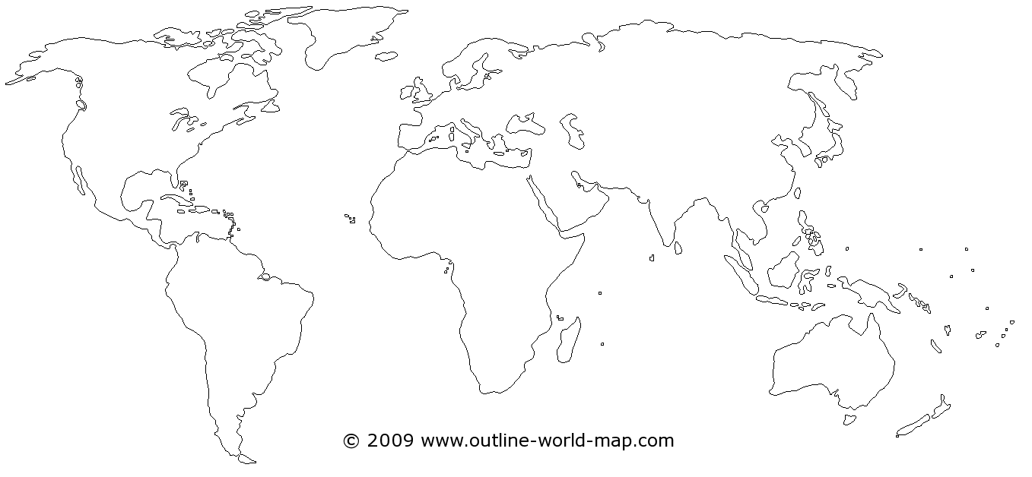

Chinese Slavery