How Communism Works
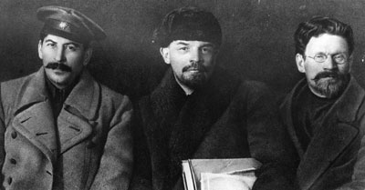
Russian revolutionaries and leaders Joseph Stalin, Vladimir Ilyich Lenin and Mikhail Ivanovich Kalinin at the Congress of the Russian Communist Party.

Introduction to How Communism Works
In a perfect world, everyone would have food and shelter, and a true utopian society would be devoid of sexism, racism and other forms of oppression. But for most of the world's population, this perfect society just isn't possible. Communism is one proposed solution to these problems.
Most people know what communism is at its most basic level. Simply put, communism is the idea that everyone in a given society receives equal shares of the benefits derived from labor. Communism is designed to allow the poor to rise up and attain financial and social status equal to that of the middle-class landowners. In order for everyone to achieve equality, wealth is redistributed so that the members of the upper class are brought down to the same financial and social level as the middle class. Communism also requires that all means of production be controlled by the state. In other words, no one can own his or her own business or produce his or her own goods because the state owns everything.
According to the philosopher Frederick Engels' "Principles of Communism," the plan for ultimate financial and social equality is built on the principle that the system should spread around the world until all countries are on board [source: Engels]. This central goal has caused capitalist nations to keep their guards up, fearing that communist economic practices might spread to their countries.
Who are communists, and why do non-communist cultures consider them radical? Does communism work in practice? Next, we'll take a look at the father of communism.
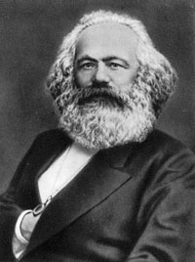
Karl Marx, the father of communism

Communist Theories and Principles
The political theory of socialism, which gave rise to communism, had been around for hundreds of years by the time a German philosopher named Karl Marx put pen to paper. Marx, also known as the father of communism, spent most of his life in exile in Great Britain and France. He wrote the Communist Manifesto in 1848, which later served as the inspiration for the formation of the Communist Party. Communism is also known as "Marxism."
Marx believed that a truly utopian society must be classless and stateless. (It should be noted that Marx died well before any of his theories were put to the test.) Marx's main idea was simple: Free the lower class from poverty and give the poor a fighting chance. How he believed it should be accomplished, however, was another story. In order to liberate the lower class, Marx believed that the government would have to control all means of production so that no one could outdo anyone else by making more money. Unfortunately, that proves to this day to be more difficult than he might have realized.
Marx described three necessary phases toward achieving his idea of utopia.
- Phase 1: A revolution must take place in order to overthrow the existing government. Marx emphasized the need for total destruction of the existing system in order to move on to Phase 2.
- Phase 2: A dictator or elite leader (or leaders) must gain absolute control over the proletariat. During this phase, the new government exerts absolute control over the common citizen's personal choices -- including his or her education, religion, employment and even marriage. Collectivization of property and wealth must also take place.
- Phase 3: Achievement of utopia. This phase has never been attained because it requires that all non-communists be destroyed in order for the Communist Party to achieve supreme equality. In a Marxist utopia, everyone would happily share property and wealth, free from the restrictions that class-based systems require. The government would control all means of production so that the one-class system would remain constant, with no possibility of any middle class citizens rising back to the top.
Marx also detailed the 10 essential tenets of communism, namely:
- Central banking system
- Government controlled education
- Government controlled labor
- Government ownership of transportation and communication vehicles
- Government ownership of agricultural means and factories
- Total abolition of private property
- Property rights confiscation
- Heavy income tax on everyone
- Elimination of rights of inheritance
- Regional planning
In the communist society that Marx described, the government has supreme authority through its total control of land and means of production. Because the government distributes land and property among the people, communism sets a standard of equality -- both economically and socially -- among its followers.

